IML ex6 – Tal Getz – 212554026

Practical Part

1.

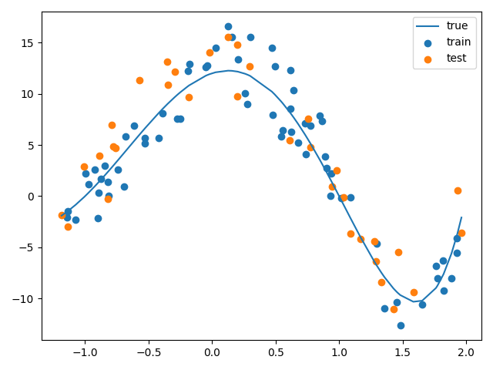

2.

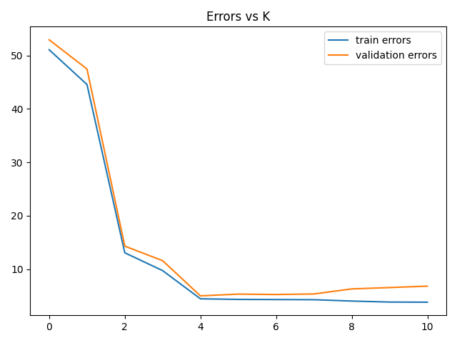

We got results which show a minimum at k=4, hinting at a polynomial of 4th degree (despite the fact that ours is of the 5th degree, but it makes sense that lowering k and adding bias would assist in lowering the error due to the added noise).

The validation error is slightly higher than the train error which makes sense, and as the train error keeps lowering as we increase k (and the variance), the test error increases due to the high variance.

3.

best k value: 4, test error: 4.47, validation error: 5.01

the test error is slightly better due to the larger amount of data available for training when using all 100% of the train data for training the model and not only 80%.

4.

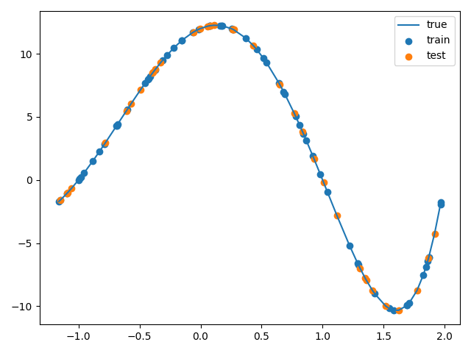

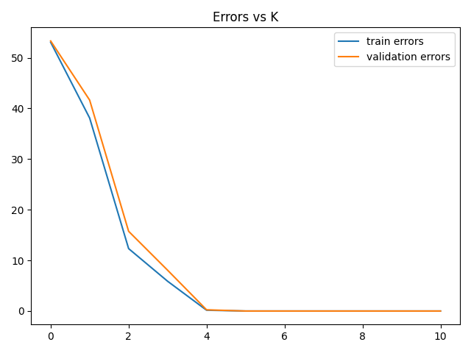

best k value: 5, test error: 3.06e-26, validation error: 1.56e-27

We received a MUCH lower error on the 5th degree polynomial this time due to us having no noise, in which case the train and test data are exactly the same and only 6 points are required to fit a polynomial of 5th degree with 6 free coeficients.

the train and test errors are very similar and very low due to this.

Also the test error is very small aswell.

5.

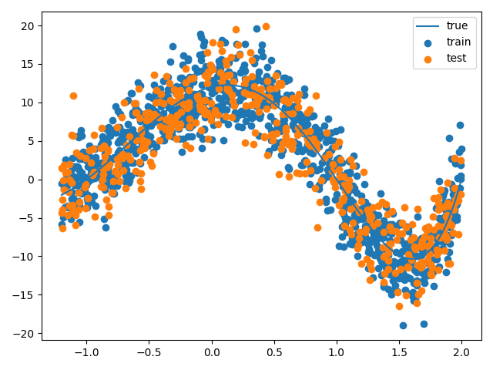 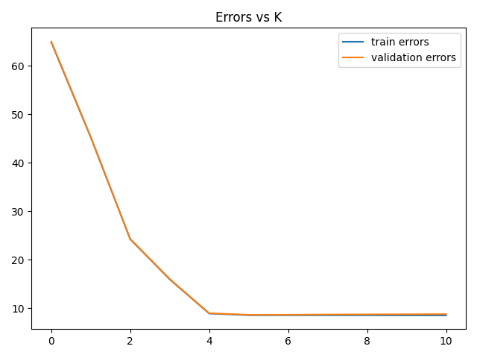

best k value: 5, test error: 8.53, validation error: 8.62

we see due to the large amount of data the train dataset resembles the test dataset very much, and therefore allows our model to predict it well with little added error. Also the error is relatively low despite the large amount of noise.

6.

Did it.

7.

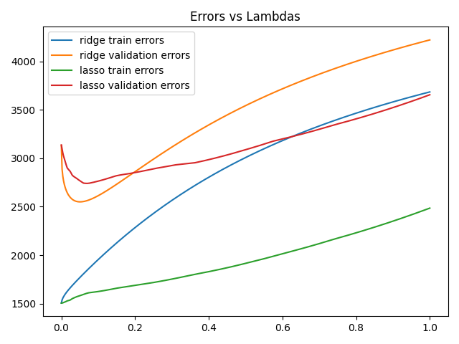

We can see train results improve as we lower lambda, which makes sense as we increase the variance and lower the bias, therefore overfitting on the data.

The validation results however have a minimum at a certain lambda after which they begin to underfit.

Also it makes a lot of sense for them to be a lot higher than the train errors.

It is interesting to note that the ridge algorithm performs better than the lasso algorithm.

8.

The lambdas:

Ridge Lambda: 0.0501096993987976

Lasso Lambda: 0.06814559118236473

The errors:

Ridge Error: [3423.25591807]

Lasso Error: [3374.14711724]

Least Squares Error: [3765.38274227]